LinkedIn

To register your application on LinkedIn, follow this instruction.

1. Go to the LinkedIn Developer Console from the link: <https://developer.linkedin.com/>.  
Select the item "My applications".

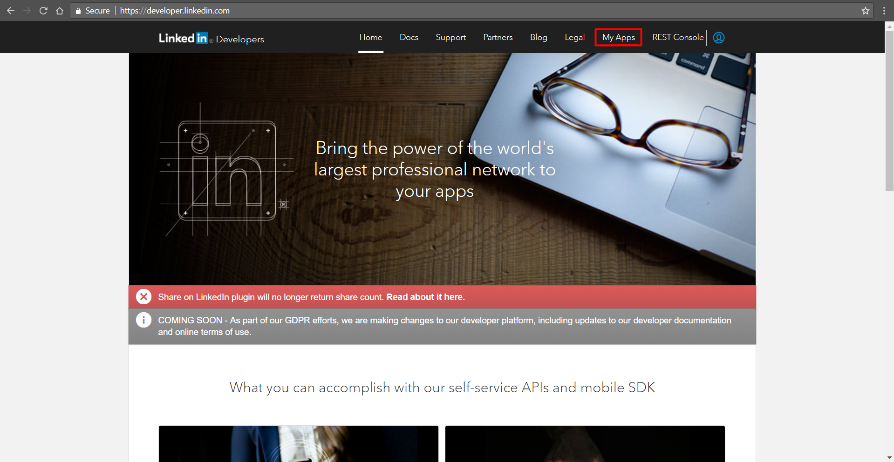

2. Click the button "Create an application"**.  
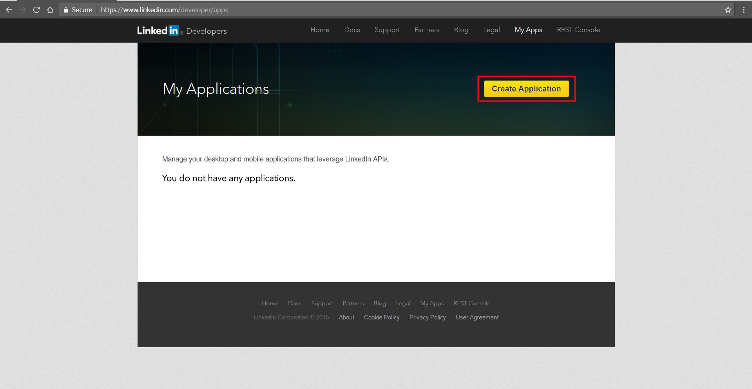**

**3. Create an Application.**

3.1 Fill in the required fields.  
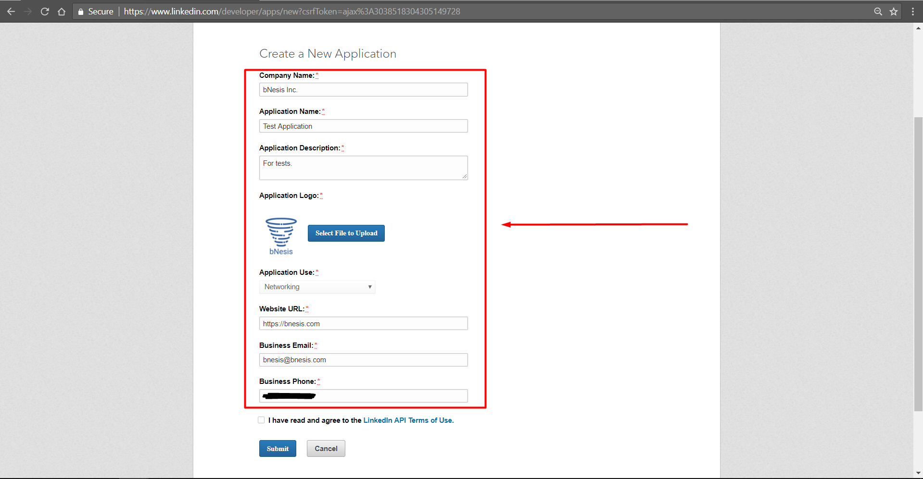 **Note: The height and width of the logo must be the same**.

3.2 Put a tick in front of the inscription

"I have read and accept the terms of use of the LinkedIn API."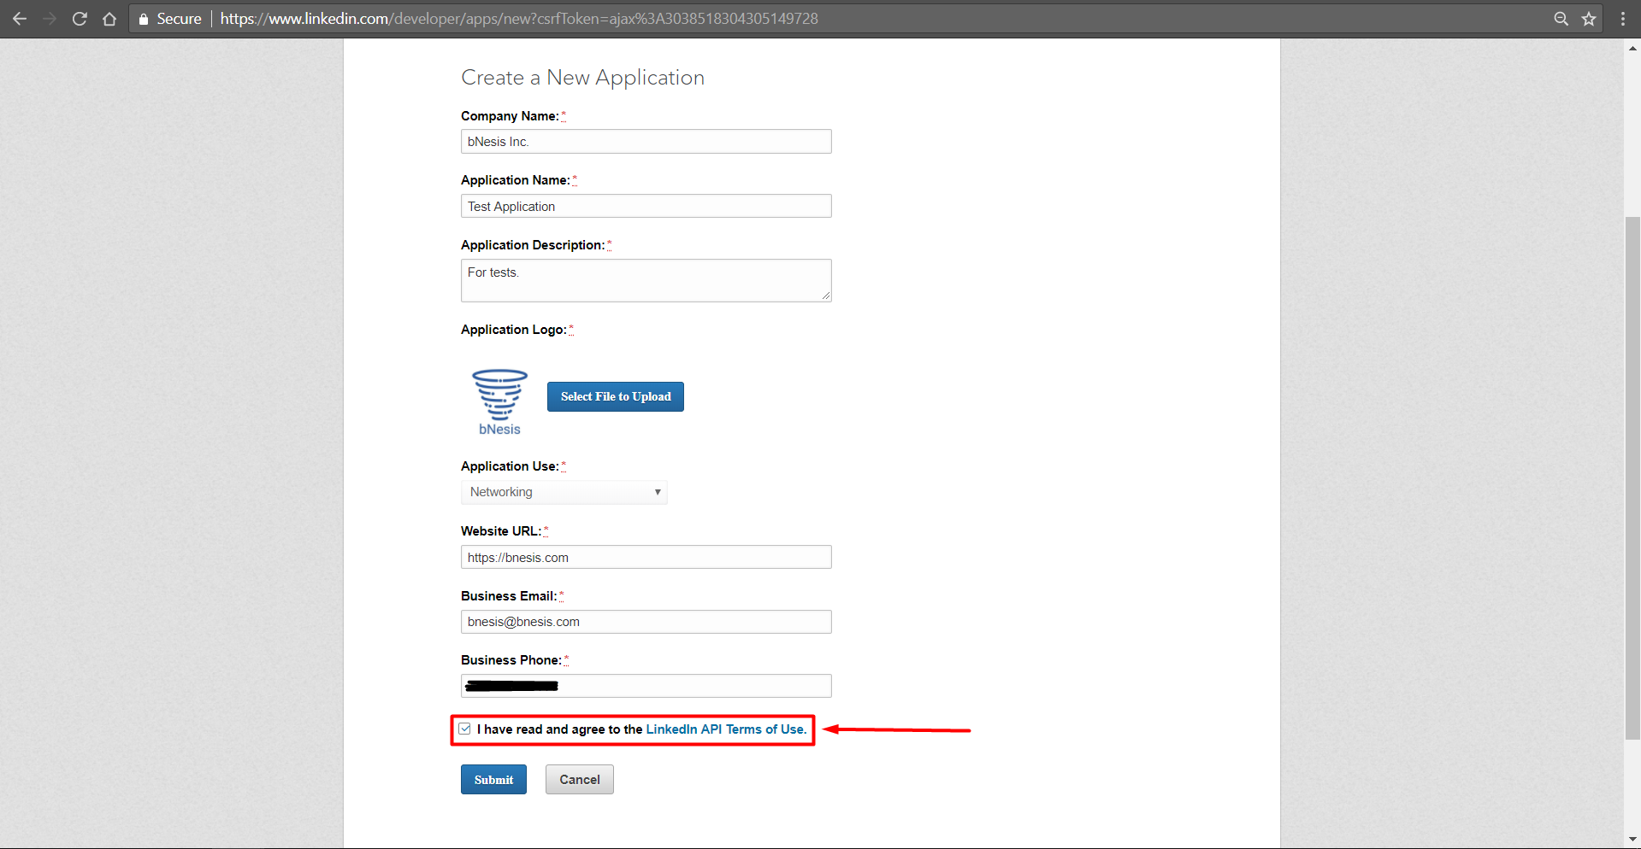  
3.3 Click on the button "Confirm".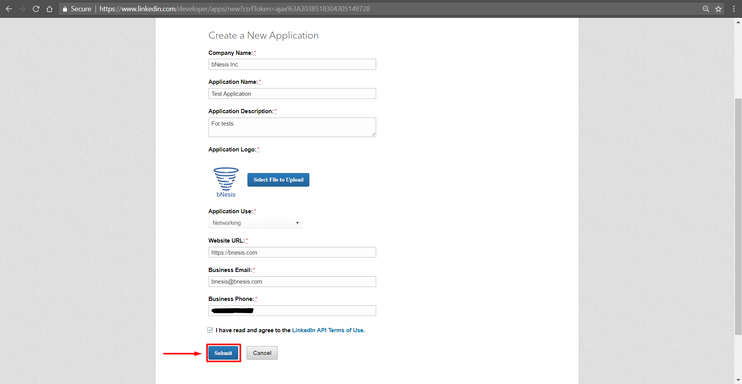

**Note. After the Confirmation, you will be redirected to the application page**.

**4. Allowed redirect URL for the application.**

4.1 After the application is registered, you need to add a return address to which LinkedIn will return an access key (token) after authorization.

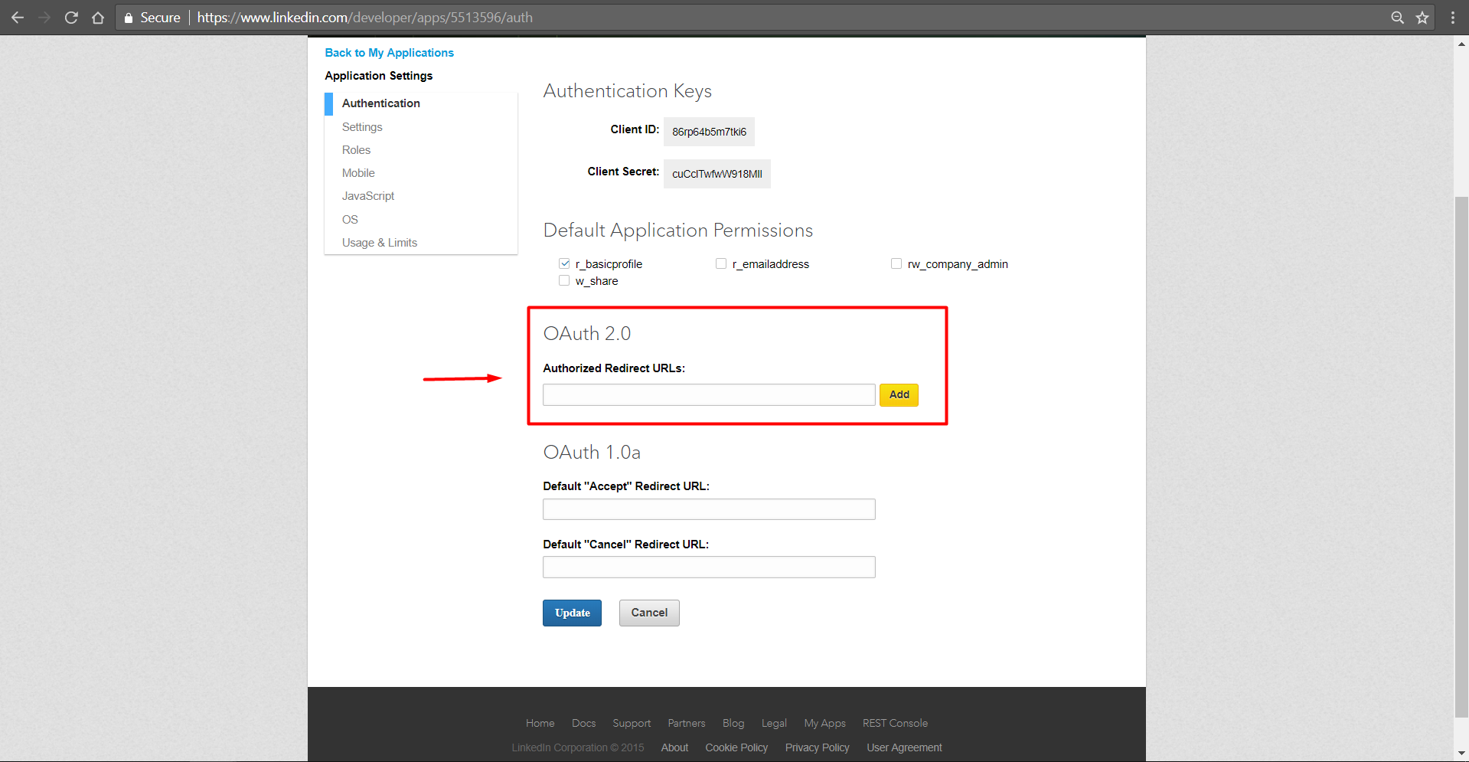

For example, in an empty field we write: [**https://server2.bnesis.com/signin-linkedin**](https://server2.bnesis.com/signin-linkedin).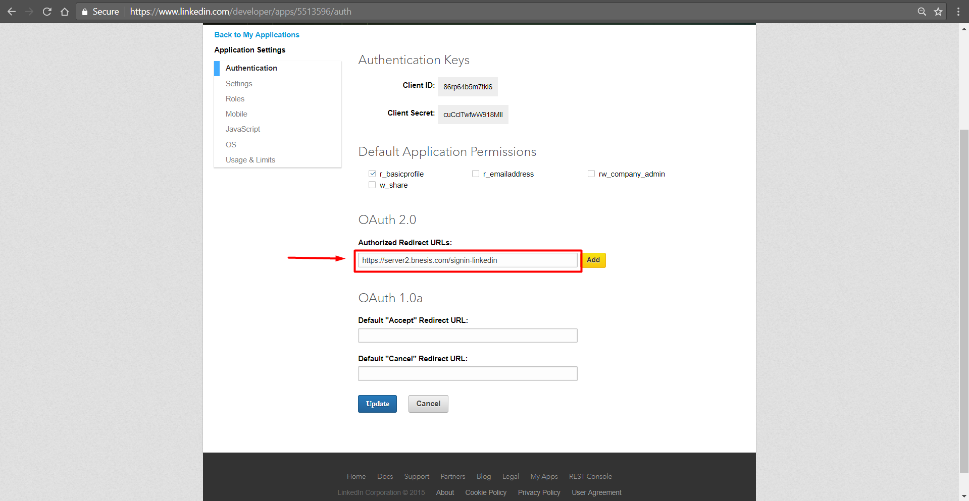

4.2Click on the "Add" button.  
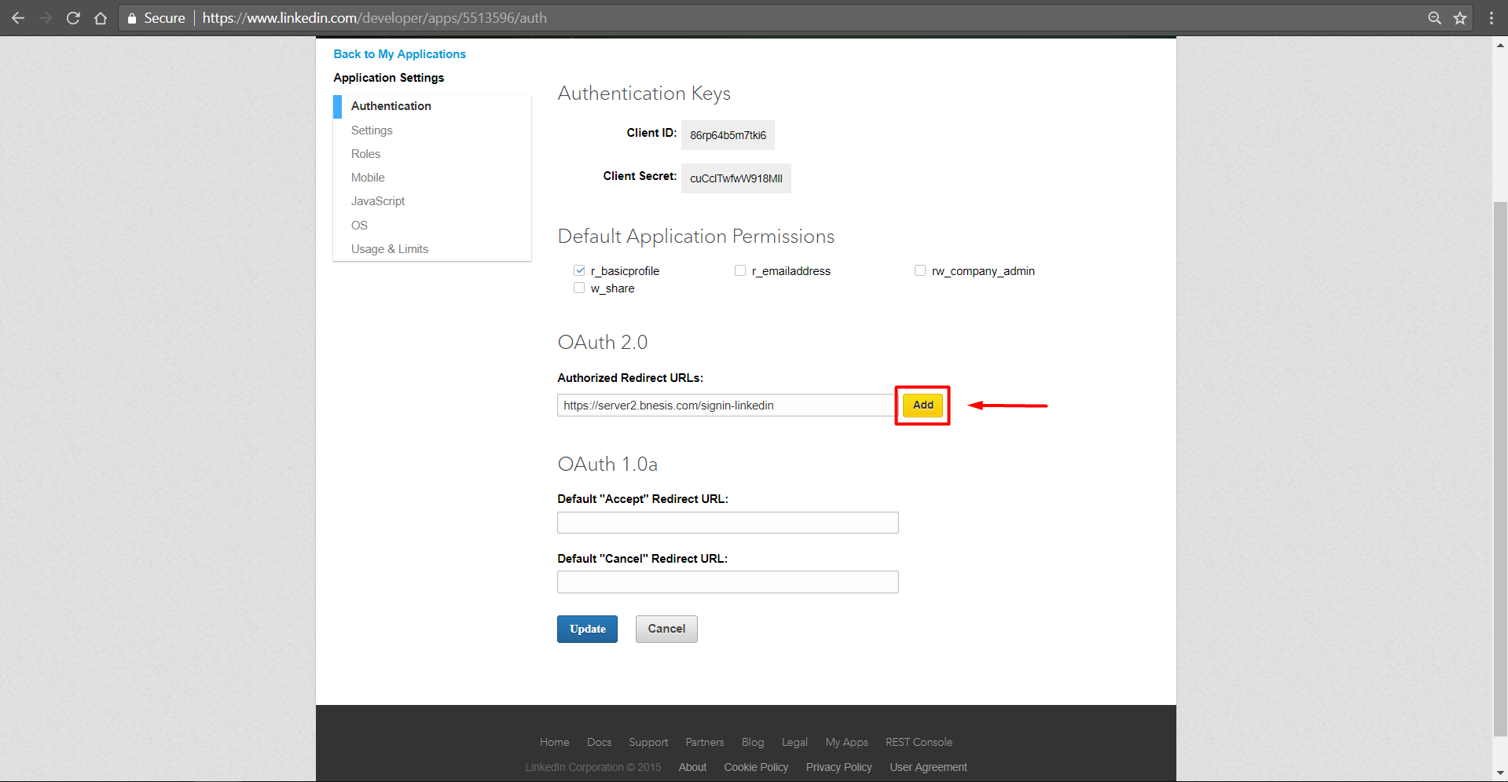

4.3 After adding the return address, we click on the "Update" button.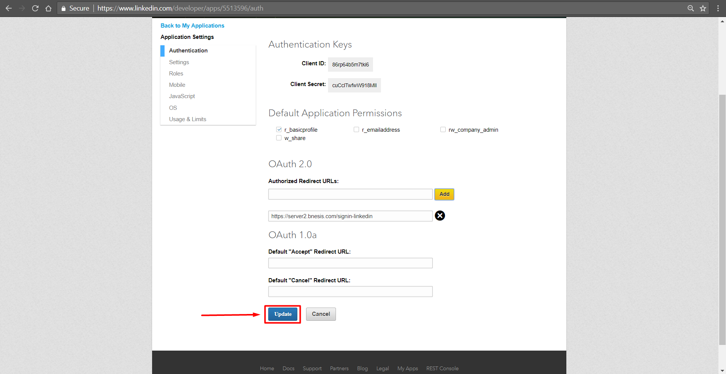

**5. Completion.**

5.1 Copy the keys: Your Customer ID and Client Secret for the bNesis application. 